Merge Conflict

A merge conflict occurs in version control systems, such as Git, when two or more branches or contributors make conflicting changes to the same part of a file or codebase. This conflict arises during the process of merging one branch into another. When the system cannot automatically determine which changes to keep, it prompts the user to resolve the conflict manually. To resolve a merge conflict, the conflicting changes must be reviewed, edited, and harmonized so that a coherent and acceptable version of the code can be merged without errors.

Step#1:



Step#2: Step#3:

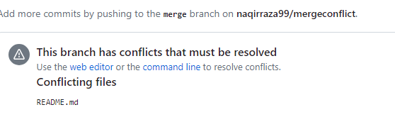

Step#4: Step#5:

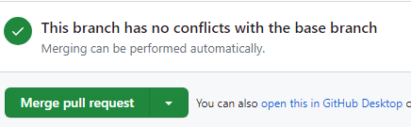

Step#6:

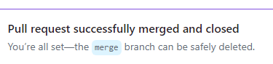Step#7:

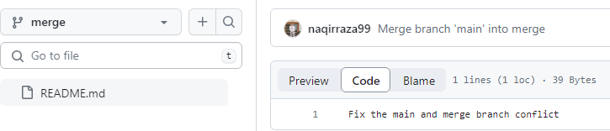

Step#8:

